TDA-GO Quarterly Report Instructions

Click here to access the TDA-GO website or copy and paste the following in your browser: https://tda-go.intelligrants.com/

- Log in to TDA-Go by entering your username and password.
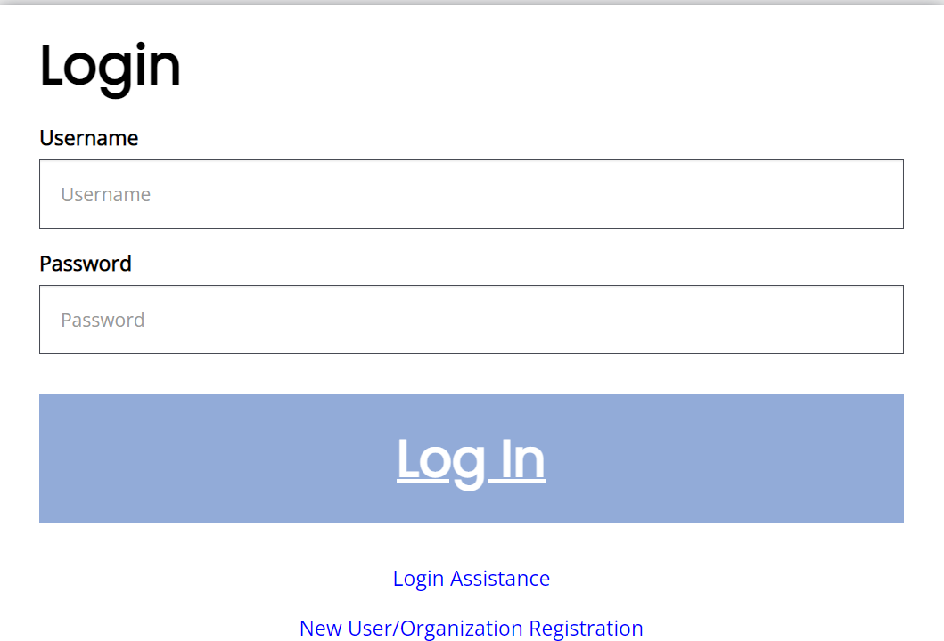

- On the Dashboard you can search for your grant project ID Performance Report which shows up as a task that needs to be completed under “My Tasks”.
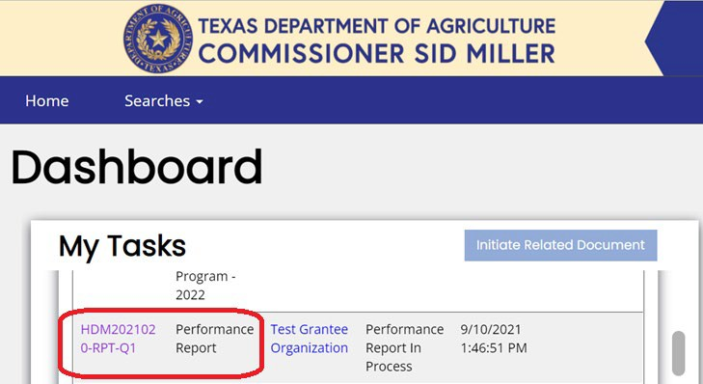

You can scroll until you find the one you want or use the filter to narrow down the ones that need a report completed.
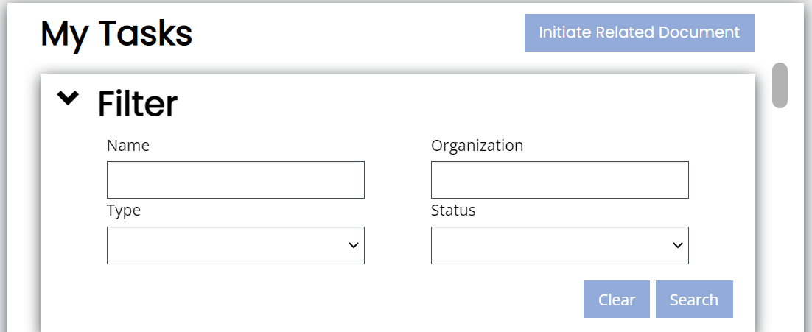

- Navigate to Forms and click “HDM-Quarterly Grant Report” in the tool bar on the left.

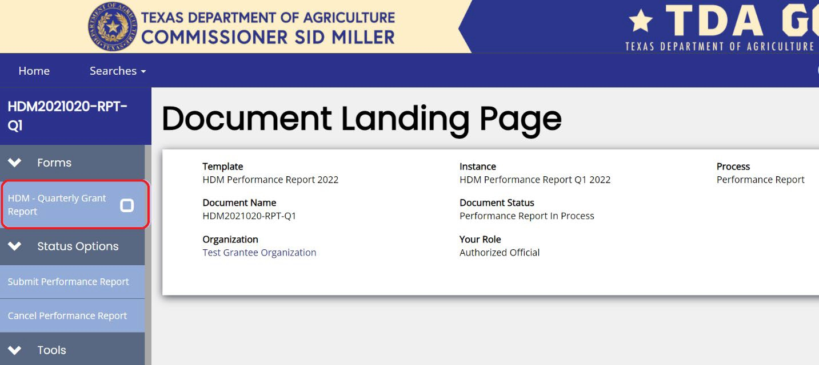

- Begin filling out your quarter report.

Entering Data
- Current quarter: Select the quarter you are completing a report for from the drop-down menu.

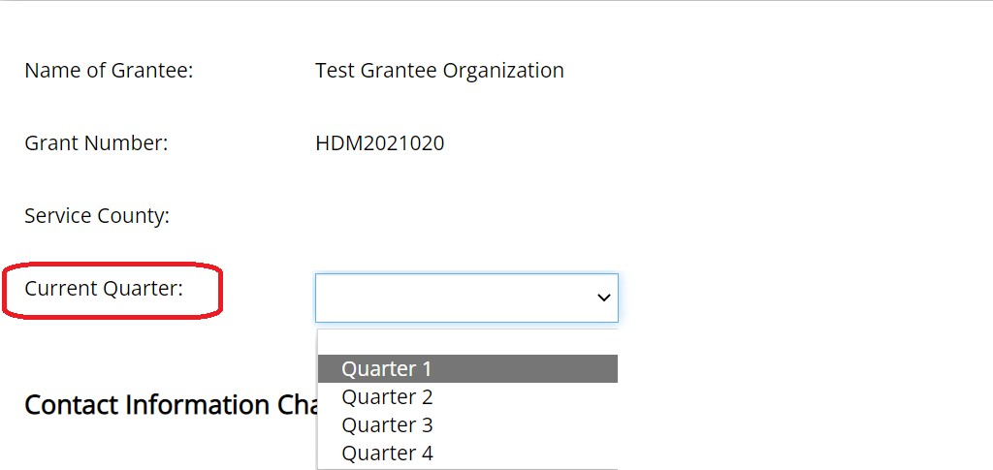

- Contact Information Changes: Select yes if your organization has had any contact or key personnel changes and please update the Applicant Contact Information page on your application after you complete your report.
Select no if there have been no changes.
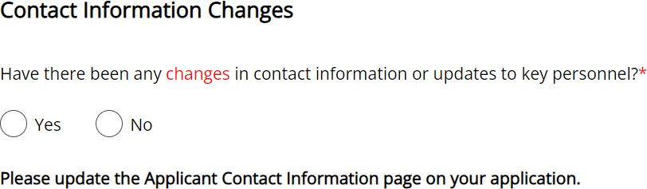

- Budget Changes: Review your budget found on the column labeled Budgeted Amount. If your budget has changed from the original budget for the current quarter, select yes and contact TDA to request a budget revision form after completing your report. Select No if there has been no changes to your budget.

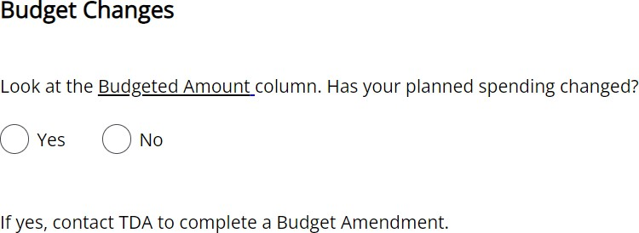

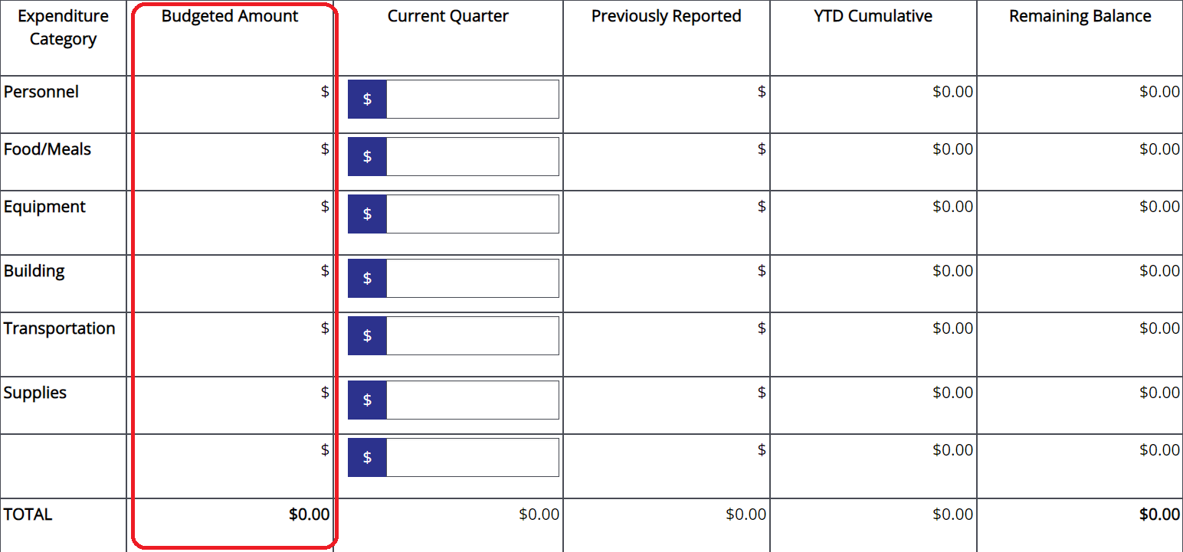

- Quantifiable Information: Enter the number of meals delivered during the current quarter, regardless of funding source in the box for question 1.
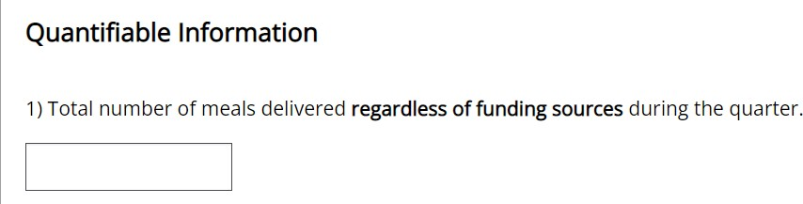
Enter the number of meals delivered during the current quarter using HDM funding, in the box for question 2.

Please do not include congregate meals in these totals.

Home-Delivered Meals Grant Utilization

- Enter expenses for the quarter in each box under the current quarter column. See tips below. If any expenses in the prior quarters need to be adjusted, please contact TDA to push your previous report back to make needed changes.

  - EXPENDITURES SHOULD NEVER TOTAL MORE THAN THE AMOUNT DISTRIBUTED BY TDA.
  - IF NO FUNDS WERE EXPENDED DURING THE QUARTER, PLEASE ENTER A ZERO.
  - ENTER ZERO IN ALL OTHER CATEGORIES THAT FUNDS WERE NOT SPENT IN.
  - PLEASE REFER TO THE COST ALLOCATION WORKSHEET FOR GUIDANCE AT THE LINK
BELOW.
https://texasagriculture.gov/Portals/0/Publications/ER/HDM/2026/FY%202026%20Cost%20Allocation%20Worksheet.xlsx?ver=_cVFX40GJhDQL203dRvUxA%3d%3d

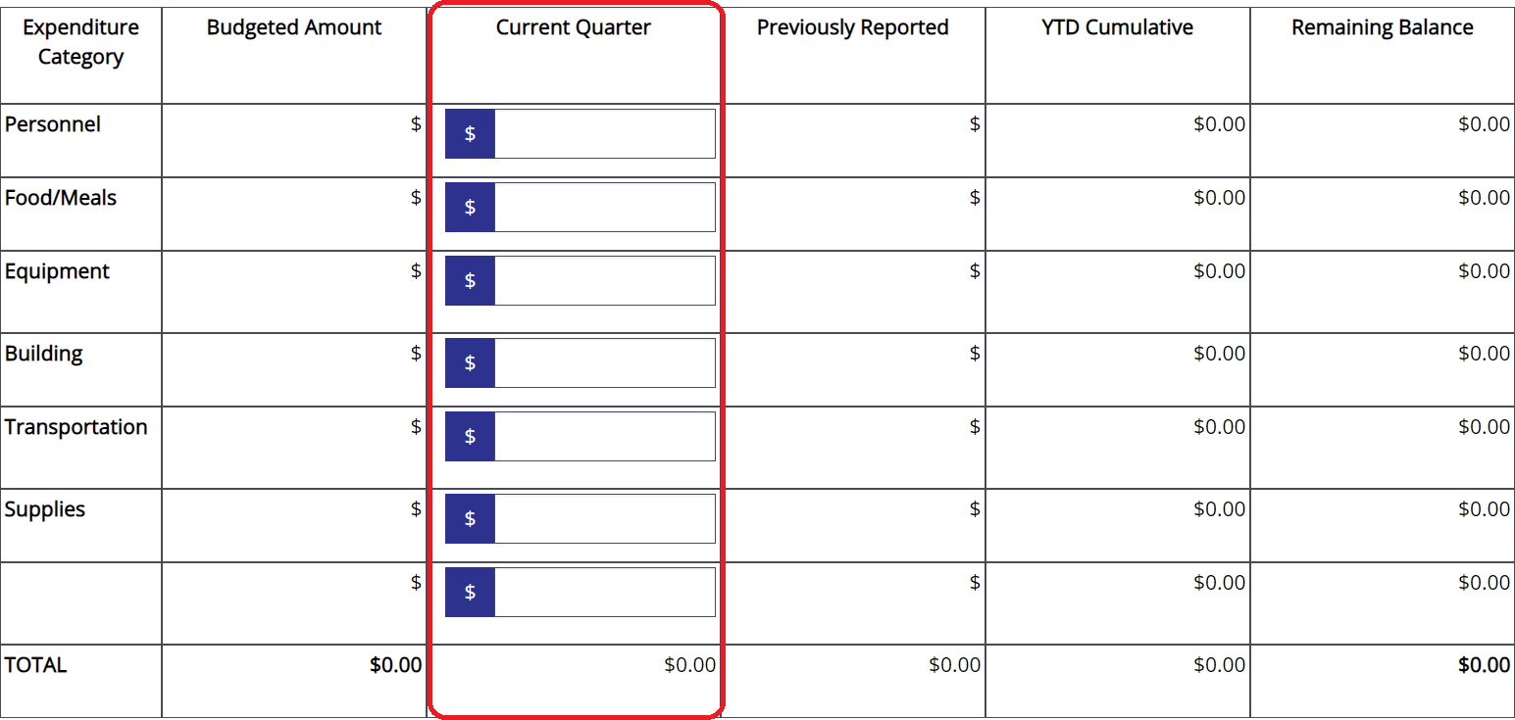

Payment Information can be reviewed at bottom of screen after this step.

- Once all report fields are completed click Save on the upper right hand corner to save your work. Then navigate to Status Options on tool bar on left side of screen and click “Submit Performance Report” to submit your report.

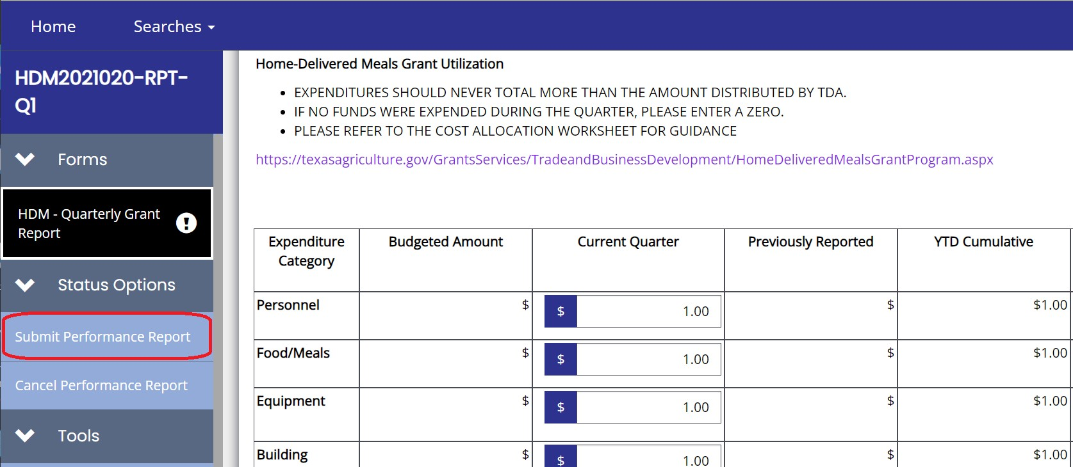

- You will be prompted to confirm submission and add any additional comments if needed.
Click OK to complete submission.
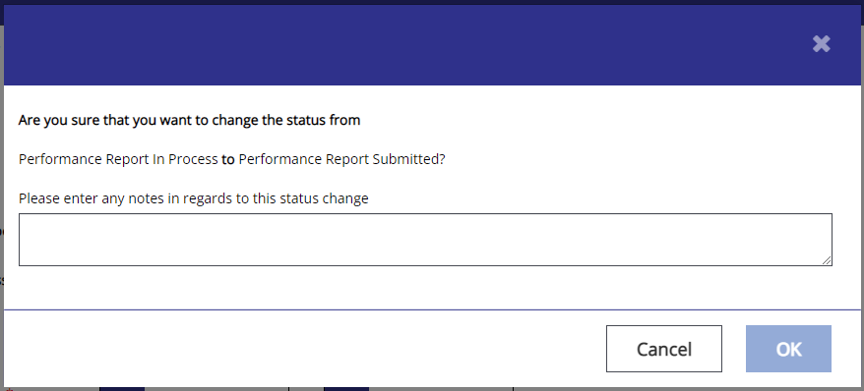

- TDA will review and approve report. You will receive email notification once your report has been approved, but you can also check the status of your report in the system.

